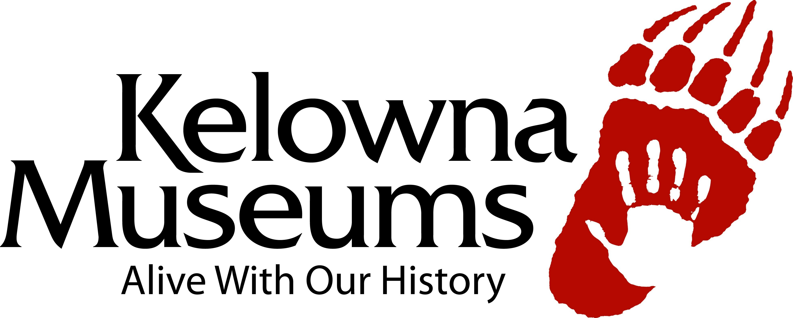

Volunteer Application Form

Thank you for your interest in volunteering with the Kelowna Museum Society!

Contact Information:
First Name: Last Name:
Address: City:
Province: Postal Code: Telephone:
Email:

Emergency Contact Information:
Name: Relationship:
Telephone: Mobile:

Please indicate when you are able to volunteer:

Mornings Afternoons Evenings Weekends

We have many options available to our volunteers. Please select your top three choices:

- Information Desk: answering phones, greeting visitors, general inquiries
(3 hour shifts between 10:00am and 5:00pm, Monday through Saturday)
- Docent: leading school programs and giving tours to groups of adults and students
(Hours vary depending on class schedules)
- Collections: organization, cataloguing, data entry, special projects
(2 hour shifts between 10:00am and 5:00pm, Tuesday through Saturday)
- Archives: assessment, data entry, scanning
(2 hour shifts between 10:00am and 5:00pm, Tuesday through Saturday)
- Special Events and Programming: set-up, decorating, greeting, clean-up, poster distribution
(Hours vary depending on events)
- Marketing: data entry, research, special projects
(Hours vary depending on projects)

List your skills, interests, education, and training:

Please submit applications and inquiries to:
Museum Services Coordinator
470 Queensway Avenue
Kelowna, BC V1Y 6S7
Tel: 250-763-2417
info@kelownamuseums.ca

