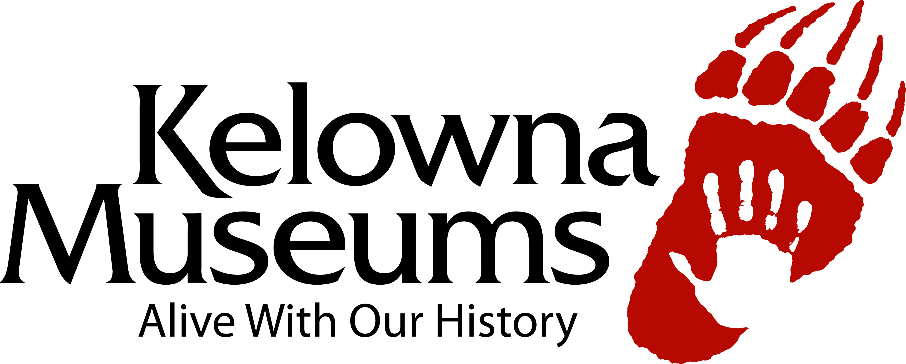
Job Posting

The Kelowna Museums Society is looking to add to its pool of casual Event Assistants. Although primary scheduling would revolve around evening and weekend events at the historical Laurel Packinghouse, there are also occasional daytime shifts available for the welcome desks at any of our three locations within the Cultural District. The Event Assistant is often the first point of contact for visitors and/or rental clients, and, as such, represents the Kelowna Museums to the public – enthusiasm, engagement, and a strong customer service focus are the keys to success for this position.

Primary Duties:
- Be on hand to welcome visitors or renters, and respond to general inquiries
- Be present and visible to renters during events
- Support renters during their event by keeping rental areas stocked and tidy
- Assist in setting up, cleaning or other assistance during or at closing of events
- Help correct any problems with lighting, sound system, internet access, etc.
- Remind renters when last call and closing times are approaching
- Ensure renters are following rental agreement guidelines
- Monitor building interior and exterior
- Call on the appropriate external resources if assistance is needed
- Opening and/or closing of building
- Maintain log book and prepare reports or recommendations
- Identify and report any issues that could impact health, safety or security
- Occasional daytime front desk coverage

Secondary Duties
- Assist customers of the Gift Shop when necessary
- Promotes a positive team atmosphere
- Maintains acceptable appearance and conduct standards

Qualifications
- Be reliable and able to work flexible hours
- Be able to consistently deliver a high level of customer service
- Be physically able to lift up to 40 lbs and able to set-up or take-down tables and chairs
- Be able to work without supervision and make decisions using good judgement
- Good understanding of general workplace and/or event protocols and safety
- Serving It Right Certificate
- Valid Class 5 BC Driver’s License preferred
- A satisfactory Criminal Record Check
- POS experience would be an asset
- An Emergency First Aid Certificate would be an asset

Salary: $14.50 per hour to start

Apply: Apply to hr@kelownamuseums.ca

